Zoom Music and Dancing for Adults with Special Needs 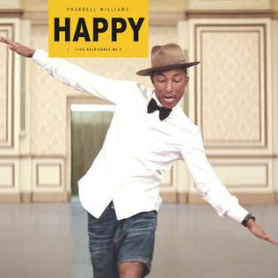
This Photo by Unknown Author is licensed under CC BY-SA

What is it? An eclectic mix of songs spanning across the genres all the way from Moon River by Andy Williams to Uptown Funk by Bruno Mars. Simple stretches and movements that have been choreographed to each song have been carefully selected to improve range of motion and provide a structure for physical fitness.
Ideal Audience: Older teens and young adults with special needs and who love music and would benefit from daily exercise. Exercises are simple and repetitive, but intended to improve balance, range of motion, and cardio stamina.
When: Tuesday and Thursdays. 3 pm for the month of August 2020. Registration ongoing.
Cost: $20 per week, per family
Where: Online using the Zoom platform. Simply click on the link provided after registration.
Who: Kathleen Rooney, a multi-talented clinician with 29 years experience working directly with families and their children in the development and delivery of intervention services and training. Kathleen offers a wide range of clinical services that are determined individually for each child based on a thorough needs assessment. Services are provided online and in person.
All of Kathleen’s services on fine and gross motor development, sensory processing, communication, cognition, employability, and social skills are supported by training, experience and an empathic approach.
Developer and creator of original programs for pre-school sensory motor development, young adult family contribution, and work skills training. Effective training and workshop presenter for schools, teachers, parents, university students and children on a wide range of subjects, including neurodevelopment, understanding ASD, building a structure for fine motor development and sensory integration.
To register or to inquire about trying the service for one session for free, please contact kathleen@kathleenrooney.ca.

