Music and Dancing Fun for Kids
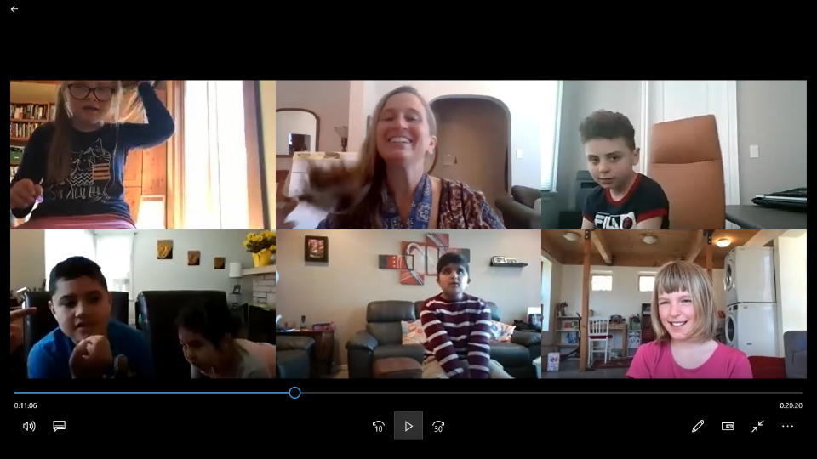

Start Date: Monday-Friday (until the pandemic is over).
Time: 10:30 am (children with special needs) or 4:00 pm (preschoolers)
Location: Virtual class via ZOOM upon invitation
Fee: $40/week (5 sessions) per household. Great value!
Facilitated by : Kathleen Rooney, a multi-talented clinician with 29 years experience working directly with families and their children in the development and delivery of intervention services and training. Kathleen offers a wide range of clinical services that are determined individually for each child based on a thorough needs assessment. Services are provided online and in person.
All of Kathleen’s services on fine and gross motor development, sensory processing, communication, cognition, employability, and social skills are supported by training, experience and an empathic approach.
Developer and creator of original programs for pre-school sensory motor development, young adult family contribution, and work skills training. Effective training and workshop presenter for schools, teachers, parents, university students and children on a wide range of subjects, including neurodevelopment, understanding ASD, building a structure for fine motor development and sensory integration.

To register or to inquire about the service, please contact kathleen@kathleenrooney.ca.

